**Experiment-3:**

**Write a program to demonstrate the working of decision tree based ID3 algorithm. Use an appropriate data set for building the decision tree and apply this knowledge to classify a new sample.**

**Analytical Analysis**

**ID3 algorithm**, stands for **Iterative Dichotomiser 3**, is a **classification algorithm** that follows a **greedy approach** of **building a decision tree** by selecting a best attribute that yields **maximum Information Gain (IG) or minimum Entropy (H)**.

Information gain tells us how important a given attribute of the feature vectors is.We will use it to decide the ordering of attributes in the nodes of a decision tree.

Information Gain = entropy(parent) – [average entropy(children)]

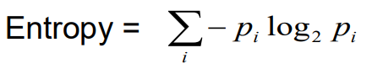

piis the probability of class i

Compute it as the proportion of class i in the set.

Entropy comes from information theory. The higher the entropy, the more the information content.

-

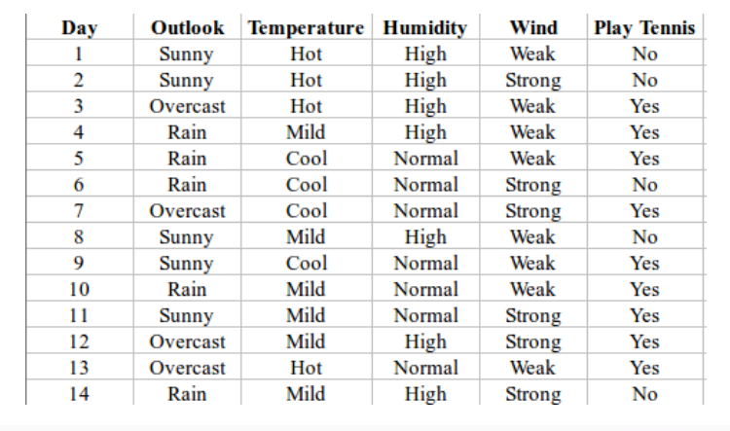

H(S) = - p(yes) * log2(p(yes)) - p(no) * log2(p(no))

= - (9/14) * log2(9/14) - (5/14) * log2(5/14)

= - (-0.41) - (-0.53)

= 0.94

**First Attribute - Outlook**

Categorical values - sunny, overcast and rain

H(Outlook=sunny) = -(2/5)*log(2/5)-(3/5)*log(3/5) =0.971

H(Outlook=rain) = -(3/5)*log(3/5)-(2/5)*log(2/5) =0.971

H(Outlook=overcast) = -(4/4)*log(4/4)-0 = 0

Average Entropy Information for Outlook -

I(Outlook) = p(sunny) * H(Outlook=sunny) + p(rain) * H(Outlook=rain) + p(overcast) * H(Outlook=overcast)

= (5/14)*0.971 + (5/14)*0.971 + (4/14)*0

= 0.693

Information Gain = H(S) - I(Outlook)

= 0.94 - 0.693

= 0.247

### Second Attribute - Temperature

Categorical values - hot, mild, cool

H(Temperature=hot)= -(2/4)*log(2/4)-(2/4)*log(2/4) = 1

H(Temperature=cool) = -(3/4)*log(3/4)-(1/4)*log(1/4) = 0.811

H(Temperature=mild) = -(4/6)*log(4/6)-(2/6)*log(2/6) = 0.9179

Average Entropy Information for Temperature -

I(Temperature) = p(hot)*H(Temperature=hot) + p(mild)*H(Temperature=mild) + p(cool)*H(Temperature=cool)

= (4/14)*1+(4/14)*0.811+(6/14)*0.9179

= 0.9108

Information Gain = H(S) - I(Temperature)

= 0.94 - 0.9108

= 0.0292

### Third Attribute - Humidity

Categorical values - high, normal

H(Humidity=high)= -(3/7)*log(3/7)-(4/7)*log(4/7) = 0.983

H(Humidity=normal) = -(6/7)*log(6/7)-(1/7)*log(1/7) = 0.591

Average Entropy Information for Humidity -

I(Humidity) = p(high)*H(Humidity=high) + p(normal)*H(Humidity=normal)

= (7/14)*0.983 + (7/14)*0.591

= 0.787

Information Gain = H(S) - I(Humidity)

= 0.94 - 0.787

= 0.153

### Fourth Attribute - Wind

Categorical values - weak, strong

H(Wind=weak) = -(6/8)*log(6/8)-(2/8)*log(2/8) = 0.811

H(Wind=strong) = -(3/6)*log(3/6)-(3/6)*log(3/6) = 1

Average Entropy Information for Wind -

I(Wind) = p(weak)*H(Wind=weak) + p(strong)*H(Wind=strong)

= (8/14)*0.811 + (6/14)*1

= 0.892

Information Gain = H(S) - I(Wind)

= 0.94 - 0.892

= 0.048

Information Gain(Outlook) = 0.247

Information Gain (Temperature)=0.0292

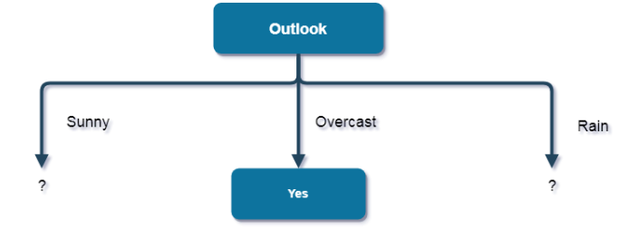

### First Attribute - Temperature

Categorical values - hot, mild, cool

H(Sunny, Temperature=hot)= -0-(2/2)*log(2/2) = 0

H(Sunny, Temperature=cool) = -(1)*log(1)- 0 = 0

H(Sunny, Temperature=mild) = -(1/2)*log(1/2)-(1/2)*log(1/2) = 1

Average Entropy Information for Temperature -

I(Sunny, Temperature) = p(Sunny, hot)*H(Sunny, Temperature=hot) + p(Sunny, mild)*H(Sunny, Temperature=mild) + p(Sunny, cool)*H(Sunny, Temperature=cool)

= (2/5)*0 + (1/5)*0 + (2/5)*1

= 0.4

Information Gain = H(Sunny) - I(Sunny, Temperature)

= 0.971 - 0.4

= 0.571

### Second Attribute - Humidity

Categorical values - high, normal

H(Sunny, Humidity=high)= - 0 - (3/3)*log(3/3) = 0

H(Sunny, Humidity=normal) = -(2/2)*log(2/2)-0 = 0

Average Entropy Information for Humidity -

I(Sunny, Humidity) = p(Sunny, high)*H(Sunny, Humidity=high) + p(Sunny, normal)*H(Sunny, Humidity=normal)

= (3/5)*0 + (2/5)*0

= 0

Information Gain = H(Sunny) - I(Sunny, Humidity)

= 0.971 - 0

= 0.971

### Third Attribute - Wind

Categorical values - weak, strong

H(Sunny, Wind=weak) = -(1/3)*log(1/3)-(2/3)*log(2/3) = 0.918

H(Sunny, Wind=strong) = -(1/2)*log(1/2)-(1/2)*log(1/2) = 1

Average Entropy Information for Wind -

I(Sunny, Wind) = p(Sunny, weak)*H(Sunny, Wind=weak) + p(Sunny, strong)*H(Sunny, Wind=strong)

= (3/5)*0.918 + (2/5)*1

= 0.9508

Information Gain = H(Sunny) - I(Sunny, Wind)

= 0.971 - 0.9508

= 0.0202

Here, the attribute with maximum information gain is Humidity. So, the decision tree built so far -  
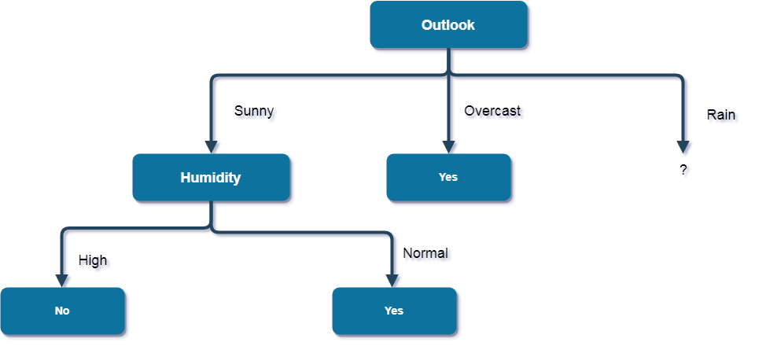

Now, finding the best attribute for splitting the data with Outlook=Sunny values{ Dataset rows = [4, 5, 6, 10, 14]}.

Complete entropy of Rain is -

H(S) = - p(yes) * log2(p(yes)) - p(no) * log2(p(no))

= - (3/5) * log(3/5) - (2/5) * log(2/5)

= 0.971

### First Attribute - Temperature

Categorical values - mild, cool

H(Rain, Temperature=cool)= -(1/2)*log(1/2)- (1/2)*log(1/2) = 1

H(Rain, Temperature=mild) = -(2/3)*log(2/3)-(1/3)*log(1/3) = 0.918

Average Entropy Information for Temperature -

I(Rain, Temperature) = p(Rain, mild)*H(Rain, Temperature=mild) + p(Rain, cool)*H(Rain, Temperature=cool)

= (2/5)*1 + (3/5)*0.918

= 0.9508

Information Gain = H(Rain) - I(Rain, Temperature)

= 0.971 - 0.9508

= 0.0202

### Second Attribute - Wind

Categorical values - weak, strong

H(Wind=weak) = -(3/3)*log(3/3)-0 = 0

H(Wind=strong) = 0-(2/2)*log(2/2) = 0

Average Entropy Information for Wind -

I(Wind) = p(Rain, weak)*H(Rain, Wind=weak) + p(Rain, strong)*H(Rain, Wind=strong)

= (3/5)*0 + (2/5)*0

= 0

Information Gain = H(Rain) - I(Rain, Wind)

= 0.971 - 0

= 0.971

Here, the attribute with maximum information gain is Wind. So, the decision tree built so far -

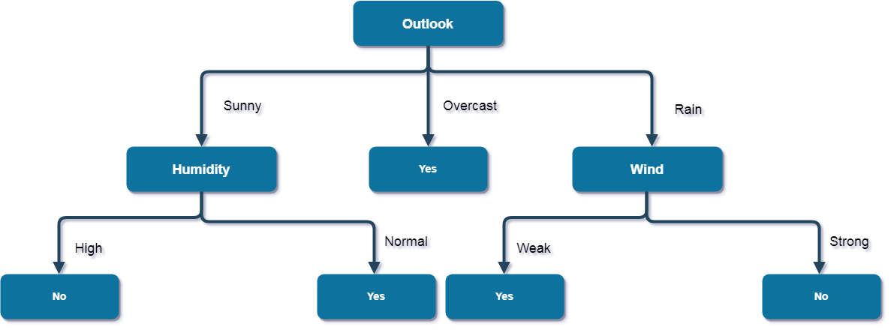

Here, when Outlook = Rain and Wind = Strong, it is a pure class of category "no". And When Outlook = Rain and Wind = Weak, it is again a pure class of category "yes".  
**And this is our final desired tree for the given dataset.**